Budget Rent A Car 
of British Columbia

Global Information System

Claims Business Design

Version 1.00

Note: The information contained in this document is confidential and may not be disclosed to any parties outside of Budget Rent a Car of British Columbia without written consent by one of its officers.
Copyright (C) 2000 Budget Rent a Car of British Columbia
Table of Contents
1. Functional Area Business Design 1
1.1. Claims 1
1.1.1. Process Description 1
1.1.1.1. Outstanding Questions 1
1.1.1.2. Design Changes Made While Preparing Document 1
1.1.2. Screens 2
1.1.2.1. Claims Screen 2
1.1.2.2. Claims Search Screen 10
1.1.2.3. Vehicle Movement Screen 16
1.1.2.4. Vehicle Damage Report Screen 20
1.1.2.4.1. Renter/Driver Tab 28
1.1.2.4.2. Incident Details Tab 39
1.1.2.4.3. Other Vehicles Tab 45
1.1.2.4.4. Property Damage Tab 52
1.1.2.4.5. Injuries 56
1.1.2.4.6. Statement 58
1.1.2.4.7. Internal 60
1.1.3. Reports 63
1.1.3.1. Vehicle Damage Report 63
1.1.3.2. tbd 63
1.1.4. Retrofits to Existing Screens 64
1.1.4.1. Contract Changes During Rental – Replace Vehicle Tab 64
1.1.4.2. Contract Check In – Check In Tab 64
1.1.4.3. Contract Adjustments – Payment Tab 64
1.1.4.4. Vehicle Support Incident – Details Tab 65
1.1.4.5. Foreign Check In – Check In Tab 65
1.1.4.6. Vehicle Movement 66
1.1.5. Tables without Maintenance Screens 67
1.1.6. Data Model 68
2. Revision History 69
2.1. Version 2.00 69

Functional Area Business Design

Claims

Process Description
This document contains the business design for claims part 1, which consists of claim number assignment and retrieval and the entry and retrieval of vehicle damage reports. The remainder of the claims business design has been deferred until after the implementation of Phase 1 of GIS.

Outstanding Questions
- What should we record in the Renter/Driver tab for damage reports where no-one was driving when the incident occurred (hit and run, vandalism, theft, etc.). Do we need another radio button (‘vehicle not being driven at time of incident’)?
- What do we want to do with Vehicle Model in the Vehicle Damage Report header if the damage report is for a Non-GIS contract? There is nowhere on the Claim screen to enter this.

Design Changes Made While Preparing Document
- On the Incident Details tab, I have moved Location of Incident to the right hand side of the screen so that it is entered after Report Type and Reported By.
- On the top of the Vehicle Damage Report screen I have added a display only status (Incomplete or Complete).
- I have removed the Retrieve and Search buttons from the Vehicle Damage Report screen. All search and retrieval is done through the Claims screen.

Screens

Claims Screen
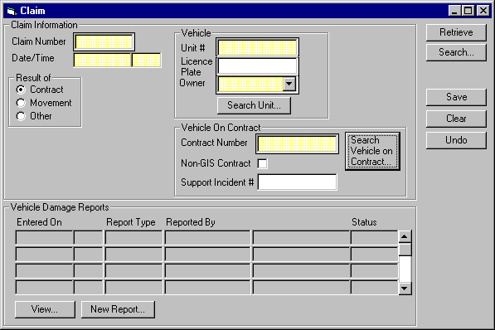

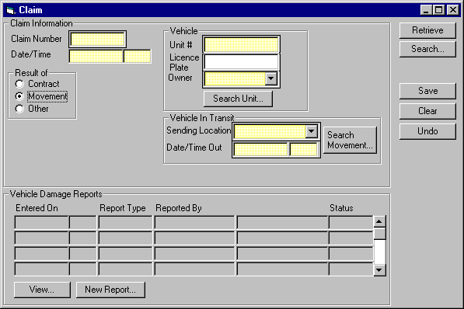
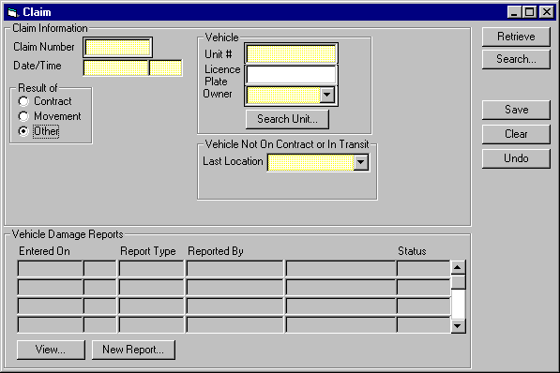
Purpose
The Claims screen is used for opening new claims and entering damage reports for them and for recording and viewing damage reports for existing claims.
Save, Clear, and Undo buttons are available at the right hand side of the screen.
Opening a New Claim
A new claim is opened by entering the claim information in an empty screen and hitting Save.. Every claim that is opened must be linked to a vehicle and may be linked to either a vehicle on contract or to a vehicle movement. If a claim is not linked to a contract or movement, it is linked to the last known location of the vehicle.
When the claim is saved, GIS will assign a unique claim number.
Viewing an Existing Claim
An existing claim can be retrieved by entering the claim number and hitting Retrieve or by using the Search button to open the Claims search screen and selecting a claim through it.
When an existing claim is retrieved, none of the claim information can be updated.
Screen Hierarchy
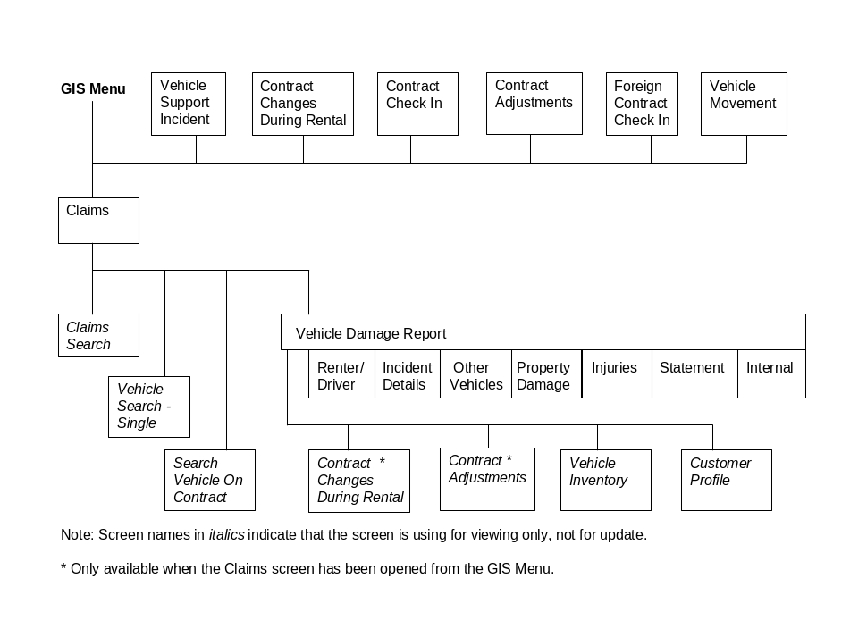
Navigation
Search: Opens the Claims Search screen. Once a claim is selected in the search screen, the search screen will be closed and the Claims screen will be populated with the information for that claim. Enabled when the screen is first opened and after the Clear button has been used. Disabled after the Claim screen has been populated with an existing claim using the Retrieve or Search buttons or when any data for a new claim has been entered.
Search Unit: Opens the Vehicle Search - Single screen, populated with the fields
entered in the vehicle section and the search results for those fields. If a vehicle is selected, the Vehicle Search - Single screen will be closed and the vehicle selected will be used to populate the Claim screen. Enabled when any data for a new claim has been entered. Disabled if an existing claim has been retrieved.
Search Movement: Opens the Vehicle Movement Search screen, populated with the fields
entered in the unit section and the search results for those fields. If a movement is selected, the Vehicle Movement Search screen will be closed and the movement selected will be used to populate the Claim screen. Enabled when a new claim has been set up using the New Claim button. Disabled if an existing claim has been retrieved.
Search Vehicle Opens the Vehicle On Contract Search screen, populated with the fields
On Contract: entered in the vehicle and vehicle on contract sections and the search results for those fields. If a Vehicle On Contract is selected, the Vehicle On Contract Search screen will be closed and the Vehicle On Contract selected will be used to populate the Claim screen. Enabled when a new claim has been set up using the New Claim button. Disabled if Non-GIS Contract is turned on or if an existing claim has been retrieved.
Functions
Retrieve: If a Claim Number is entered, the screen will be populated with the information for that claim. Otherwise, the Claims Search screen will be opened. Once a claim is selected in the search screen, the search screen will be closed and the Claim screen will be populated with the information for that claim. Enabled when the screen is first opened and after the Clear button has been used. Disabled after the Claims screen has been populated with an existing claim using the Retrieve or Search buttons or when any data for a new claim has been entered.
View: Opens the Vehicle Damage Report screen for the damage report selected. Disabled unless a damage report is selected.
New Report: Opens the Vehicle Damage Report screen for a new damage report. Disabled until the claim has been saved.
Controls
Req*: Y – always mandatory
N – always optional
S – sometime optional (see Comments for details)
D – display only
Field | Source | Req* | Validation | Comments
Claim Number | Claim, Claim Number | Y |  | Assigned by GIS for a new claim. Display only when an existing claim has been retrieved.
Date/Time | Claim, Occurred At | Y | Date/Time | Display only when an existing claim has been retrieved.
Result Of
Contract/  Movement/Other | Claim, Source | Y |  | Defaults to Contract. Display only when an existing claim has been retrieved.
Vehicle |  |  |  | All the fields in this section are display only when an existing claim has been retrieved.
Unit # | Claim, Unit Number | Y | Must be on the Vehicle table unless Result Of is Contract and Non-GIS Contract is Yes | Defaults to the current vehicle unit number unless the Claim screen is opened from the GIS Menu.
Licence Plate | Vehicle, Current Licence Plate | N |  | Defaults to the current vehicle licence plate unless the Claim screen is opened from the GIS Menu.
Controls (cont.)
Field | Source | Req* | Validation | Comments
Owner | Vehicle, Vehicle Owning Company | Y |  | Owning company name is displayed. Defaults to the current vehicle owning company unless the Claim screen is opened from the GIS Menu.
Vehicle On Contract |  |  |  | Only visible when Result Of is Contract. All the fields in this section are display only when an existing claim has been retrieved.
Contract Number | Claim, Contract Number | Y | Must be on the Contract table unless Non-GIS Contract is Yes | Defaults to the current contract number unless the Claim screen is opened from the GIS Menu.
Non-GIS Contract | Claim, Non-GIS Contract | N |  | Defaults to No.
Support Incident # | Vehicle Support Incident, Vehicle Support Incident Sequence | N |  | Defaults to the current vehicle support incident sequence if the Claim screen is opened from the Vehicle Support screen.
Vehicle In Transit |  |  |  | Only visible when Result Of is Movement. All the fields in this section are display only when an existing claim has been retrieved.
Sending Location | Vehicle Movement, Location Out | Y | Value controlled by Location table.  Sending Location and Date/Time Out must identify a movement for the vehicle specified above. | Location Name is shown.
Controls (cont.)
Field | Source | Req* | Validation | Comments
Date/Time Out | Vehicle Movement, Movement Out | Y
Vehicle Not On Contract or In Transit |  |  |  | Only visible when Result Of is Other. All the fields in this section are display only when an existing claim has been retrieved.
Last Location | Claim, Last Location | Y | Value controlled by Location tab. | Location Name is shown.
Vehicle Damage Reports
Entered On | Vehicle Damage Report, Occurred On | D
Report Type | Vehicle Damage Report, Type | D
Reported By | Vehicle Damage Report, Reported By/Reported By Name | D
Technical Notes
When a new claims is saved, the Claim number should be assigned as yyyynnnn where:
- yyyy is the current year
- nnnn is the next number in sequence from the last claim number assigned.

Claims Search Screen
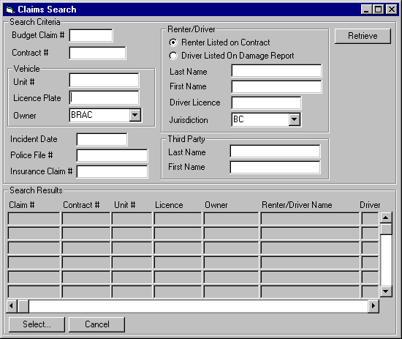
Purpose
This screen is used to search for claims using any of the following search criteria. Only claims that meet all the criteria entered will be shown in the search results list.
- Claim Number
- Contract Number
- Vehicle Unit Number and/or Licence Plate and/or Owning Company
- Incident Date
- Police File #
- Insurance Claim #
- Renter or Driver Name
- Renter or Driver Licence Number & Jurisdiction
- Third Party Name
A list of claims that match the search criteria will be presented in ascending order by claim number and the selected claim will be returned to the Claim screen.
Navigation
Select: Returns the selected claim to the Claim screen.
Functions
Retrieve: Finds all claims that match the search criteria entered and uses them to populate the Search Results list.
Controls
Req*: Y – always mandatory
N – always optional
S – sometime optional (see Comments for details)
D – display only
Field | Source | Req* | Validation | Comments
Search Criteria
Claim Number | Claim, Claim Number | N |  | Wild cards can be used at both the start and end of the number.
Contract Number | Claim, Contract Number | N
Vehicle
Unit # | Claim, Unit Number | N
Licence Plate | Vehicle, Current Licence Plate | N
Owner | Vehicle, Vehicle Owning Company | N
Incident Date | Vehicle Damage Report, Occurred On | N
Police File # | Vehicle Damage Report, Police File Number | N |  | Wild cards can be used at both the start and end of the number.
Insurance Claim # | Vehicle Damage Insurance, Claim # | N |  | Wild cards can be used at both the start and end of the number.
Controls (cont.)
Field | Source | Req* | Validation | Comments
Renter/Driver
Renter Listed On Contract/Driver Listed on Damage Report |  | S |  | Required if any of the other fields in the Renter/Driver section are entered.
Last Name | Contract, Last Name or Vehicle Damage Report, Driver Last Name | N
First Name | Contract, First Name or Vehicle Damage Report, Driver First Name | N
Driver Licence | Renter Driver Licence, Number or Vehicle Damage Report, Driver Licence Number | N |  | Wild cards can be used at both the start and end of the number.
Jurisdiction | Renter Driver Licence, Jurisdiction or Vehicle Damage Report, Driver Licence Jurisdiction | N
Third Party
Last Name | Vehicle Damage Report Third Party, Last Name | N
Controls (cont.)
Field | Source | Req* | Validation | Comments
First Name | Vehicle Damage Report Third Party, First Name | N
Search Results
Claim Number | Claim, Claim Number | D
Contract Number | Claim, Contract Number | D
Unit # | Claim, Unit Number | D
Licence Plate | Vehicle, Current Licence Plate | D
Owner | Vehicle, Vehicle Owning Company | D
Renter/Driver Name | Contract, Last Name or Vehicle Damage Report, Driver Last Name | D |  | Only visible if one or more of the fields in the Renter/Driver section are entered as part of the search criteria.
First Name | Contract, First Name or Vehicle Damage Report, Driver First Name | D |  | Only visible if one or more of the fields in the Renter/Driver section are entered as part of the search criteria.
Driver Licence | Renter Driver Licence, Number or Vehicle Damage Report, Driver Licence Number | D |  | Only visible if one or more of the fields in the Renter/Driver section are entered as part of the search criteria.
Controls (cont.)
Field | Source | Req* | Validation | Comments
Jurisdiction | Renter Driver Licence, Jurisdiction or Vehicle Damage Report, Driver Licence Jurisdiction | D |  | Only visible if one or more of the fields in the Renter/Driver section are entered as part of the search criteria.
Incident Date | Vehicle Damage Report, Occurred On | D |  | Only visible if Incident Date is entered as part of the search criteria.
Police File # | Vehicle Damage Report, Police File Number | D |  | Only visible if Police File # is entered as part of the search criteria.
Insurance Claim # | Vehicle Damage Insurance, Claim # | D |  | Only visible if Insurance Claim # is entered as part of the search criteria
Third Party Name | Vehicle Damage Report Third Party, Last Name/First Name | D |  | Only visible if Third Party Last Name or First Name are entered as part of the search criteria.

Vehicle Movement Screen
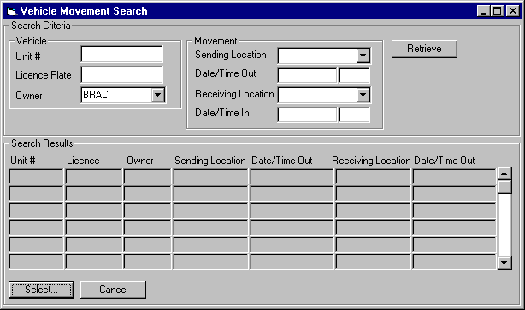

Purpose
This screen is used to search for vehicle movements using any of the following search criteria. Only movements that meet all the criteria entered will be shown in the search results list.
- Vehicle Unit Number and/or Licence Plate and/or Owning Company
- Sending Location
- Date/Time Out
- Receiving Location
- Date/Time In
A list of movements that match the search criteria will be presented in ascending order by unit number and descending order by date/time out and the selected movement will be returned to the Claim screen.
Navigation
Select: Returns the selected movement to the Claim screen.
Functions
Retrieve: Finds all movements that match the search criteria entered and uses them to populate the Search Results list.
Controls
Req*: Y – always mandatory
N – always optional
S – sometime optional (see Comments for details)
D – display only
Field | Source | Req* | Validation | Comments
Vehicle
Unit # | Vehicle Movement, Unit Number | N
Licence Plate | Vehicle, Current Licence Plate | N
Owner | Vehicle, Vehicle Owning Company | N
Movement
Sending Location | Vehicle Movement, Location Out | N | Value controlled by Location table. | Location Name is shown.
Date/Time Out | Vehicle Movement, Movement Out | N | Date/Time
Receiving Location | Vehicle Movement, Location In | N | Value controlled by Location table. | Location Name is shown.
Date/Time In | Vehicle Movement, Movement In | N | Date/Time
Controls (cont.)
Field | Source | Req* | Validation | Comments
Search Results
Unit # | Vehicle Movement, Unit Number | D
Licence Plate | Vehicle, Current Licence Plate | D
Owner | Vehicle, Vehicle Owning Company | D
Sending Location | Vehicle Movement, Location Out | D |  | Location Name is shown.
Date/Time Out | Vehicle Movement, Movement Out | D
Receiving Location | Vehicle Movement, Location In | D |  | Location Name is shown.
Date/Time In | Vehicle Movement, Movement In | D

Vehicle Damage Report Screen
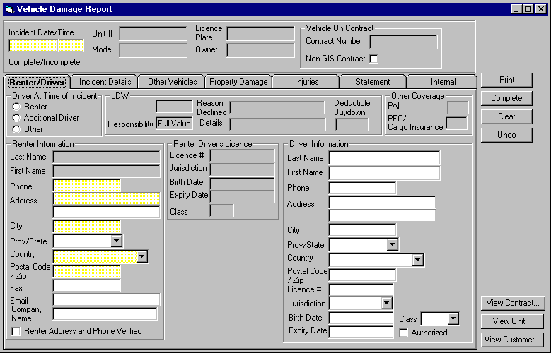

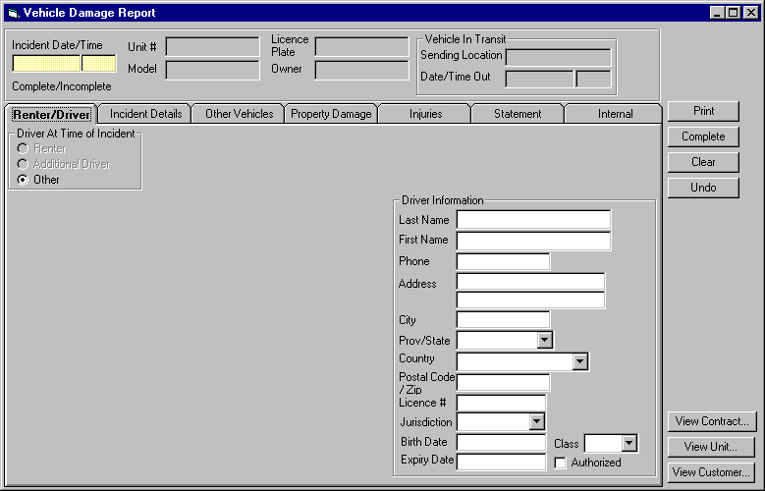
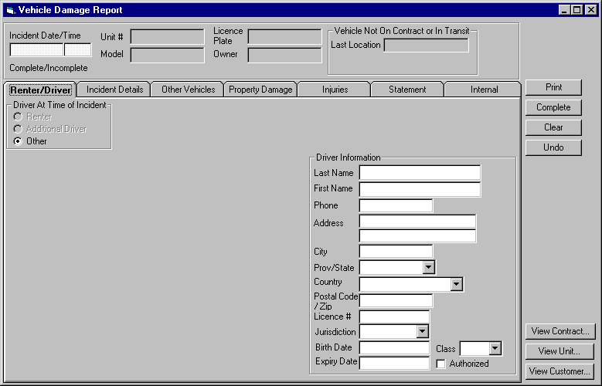
Purpose
The Vehicle Damage Report screen is used for recording details of any incidents involving:
- damage to a Budget vehicle
- damage to other vehicles involving a Budget vehicle
- injuries or property damage involving a Budget vehicle
- theft from a Budget vehicle that results in a PEC or Cargo Insurance claim being filed
Reports can be either written or verbal, depending on whether the information is given over the phone or taken in person at a Budget BC location.
For a verbal report, the person taking a report will gather as much information as they can and complete the report. Once the report is completed, it cannot be changed. If further details are provided, a new report must be created. A written report can be printed at any time before or after it is saved.
For a written report, the following procedures will be followed:
  - The CSR will take all the information from the person making the report verbally and enter it onto GIS except for:
- The statement.
- The pictures of vehicle damage and the picture of the relative positions of the vehicle(s) involved.
  - The CSR will:
- Print the damage report and have the customer review it
- If there are any changes, the updates will be entered onto GIS and the report will be reprinted.
This step can be repeated as many times as necessary. The printed report will include a picture that the customer can draw on to indicate vehicle damage and the relative positions of the vehicle(s) involved. These will have the same format as the pictures on Budget’s current vehicle damage report.
  - The customer will:
- Fill in a handwritten statement describing the incident. If the customer is unable to make a written statement, the CSR will handwrite the statement from their verbal description. If the customer refuses to make a written statement, it will be left blank.
- Draw on the printed pictures to indicate the damage the vehicle(s) involved and the relative positions of the vehicle(s) involved.
- Sign the form.
  - The CSR will:
- Give the customer a photocopy of the form
- Enter the customer’s statement into GIS (if provided).
- Press a button that indicates that the damage report is now complete. In order for this button to be used, the statement must have been entered. If the customer refused to provide a written statement, the CSR will enter the text “Customer refused to provide a written statement” instead. After this point, GIS will not allow any further changes to be made to the damage report (including changes to the internal comments), but the report can still be printed. If further details need to be recorded, a new damage report must be entered for the claim.
The screen is organized into eight areas: the base screen and seven tabs. The base screen displays the incident date and time and displays the information from the claim regarding the vehicle that the report is being filed for and the information that identifies the contract or movement that the claim results from. The tabs contain the remaining vehicle damage report information and are categorized as follows:
Renter/Driver: Where the renter information is displayed and confirmed and where information on who was driving at the time of incident is recorded.
Details: Where the damage report details are entered.
Other Vehicles: Where details on any other vehicles involved are entered.
Property Damage: Where details on any property damage are entered.
Injuries: Where details on any injuries are entered.
Statement: Where the handwritten statement is entered.
Internal: Where information that will not show on the printed damage report is entered.
Clear and Undo buttons are available at the right hand side of the screen.
Navigation
View Contract: Disabled unless the claim was opened for a GIS contract. Opens the Contract Changes During Rental or Contract Adjustments screen for Contract #, depending on whether the contract is still checked out, or has been through final check in. Whether the screens are view only or not will depend on the security access of the user.
View Unit: Disabled unless the vehicle that the claim was opened for is part of the Budget fleet inventory. Opens the Vehicle Inventory screen for the vehicle that the claim was opened for. Whether the screen is view only or not will depend on the security access of the user.
View Customer: Disabled unless the claim was opened for a GIS contract. If the contract is linked to a customer, opens the Customer screen for the customer linked to the current contract. Otherwise opens the Customer Search screen, pre-populated with the renter name from the contract and the search results for the name. Whether the screen is view only or not will depend on the security access of the user.
Functions
Print: Prints the damage report. If the damage report has not yet been saved, saves the damage report with a status of ‘Incomplete’. If the report is a written report, all required fields except for the statement must be present before the report can be printed.
Complete: Disabled until a statement has been entered if the report is a written report. Saves the damage report with a status of ‘Complete’. If the report is a written report, all required fields including the statement must be entered before the report can be completed.
Controls
Req*: Y – always mandatory
N – always optional
S – sometime optional (see Comments for details)
D – display only
Field | Source | Req* | Validation | Comments
Header
Incident Date/Time | Vehicle Damage Report, Occurred On | Y | Date/Time | This may not be the same as the date and time recorded for the claim.
Vehicle
Unit # | Claim, Unit Number | D |  | Will be on the Vehicle table unless Result Of is Contract and Non-GIS Contract is Yes
Model | Claim, Vehicle Model | D |  | Model Name is displayed.
Licence Plate | Claim, Licence Plate | D
Owner | Claim, Vehicle Owning Company | D |  | Owning company name is displayed
Vehicle On Contract |  |  |  | Only visible when Claim, Result Of is Contract.
Contract, Contract Number | Claim, Contract Number | D |  | Will be on the Contract table unless Non-GIS Contract is Yes
Non-GIS Contract | Claim, Non-GIS Contract | D |  | Defaults to No.
Controls (cont.)
Field | Source | Req* | Validation | Comments
Vehicle In Transit |  |  |  | Only visible when Claim, Result Of is Movement.
Sending Location | Vehicle Movement, Location Out | D |  | Location Name is shown.
Date/Time Out | Vehicle Movement, Movement Out | D
Vehicle Not On Contract or In Transit |  |  |  | Only visible when Claim, Result Of is Other.
Last Location | Claim, Last Location | D |  | Location Name is shown.
Technical Notes

Renter/Driver Tab
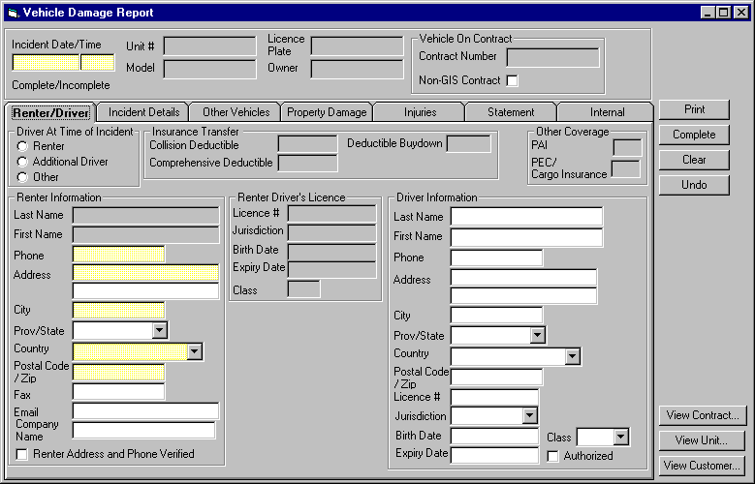
Purpose
The renter/driver tab allows the user to confirm the renter information and to record the details of who was driving the vehicle at the time of the incident. If any of the renter information is updated in this screen, it will be used to update the contract when the damage report is saved.
Navigation
N/A
Functions
N/A
Controls (cont.)
Field | Source | Req* | Validation | Comments
Driver At Time of Incident
Renter/  Additional Driver/Other | Vehicle Damage Report, Driver | S |  | No default.  Required when Report Type is Written.
Insurance Transfer |  |  |  | Only visible when Claim, Result Of is Contract, the contract is a GIS contract and the contract has an insurance transfer with both collision and comprehensive coverage.
Collision Deductible | Insurance Transfer, Collision Deductible | D
Comprehensive Deductible | Insurance Transfer, Comprehensive Deductible | D
Deductible Buydown |  | D |  | ‘Accepted’ if there is an optional extra for the contract with type ‘Buydown’ and ‘Declined’ otherwise.
Controls (cont.)
Field | Source | Req* | Validation | Comments
LDW |  |  |  | Only visible when Claim, Result Of is Contract, the contract is a GIS contract and Insurance Transfer is not visible.
(LDW) |  | D |  | ‘Included’ if LDW is included in the rate, ‘Accepted’ if there is an optional extra for the contract with type ‘LDW’ and ‘Declined’ otherwise.
Responsibility | LDW Deductible, LDW Deductible | D |  | If LDW is ‘Included, use the LDW Deductible record for the contract vehicle class and (from the contract rate) the Included Optional Extra with Type ‘LDW’.  If LDW is ‘Accepted’, use the LDW Deductible record for the contract vehicle class and the Contract Optional Extra with Type ‘LDW’.  ‘Full Value’ if LDW is ‘Declined’.
Reason Declined | Contract, LDW Declined Reason | D
Details | Contract, LDW Declined Details | D
Deductible Buydown |  | D |  | ‘Accepted’ if there is an optional extra for the contract with type ‘Buydown’ and ‘Declined’ otherwise.
Controls (cont.)
Field | Source | Req* | Validation | Comments
Other Coverage |  |  |  | Only visible when Claim, Result Of is Contract and the contract is a GIS contract.
PAI |  | D |  | ‘Included’ if PAI is included in the rate, ‘Accepted’ if there is an optional extra for the contract with type ‘PAI’ and ‘Declined’ otherwise.
PEC |  | D |  | Only visible when the Optional Extra with type PEC is not restricted for the contract Vehicle Type.  ‘Included’ if PEC is included in the rate, ‘Accepted’ if there is an optional extra for the contract with type ‘PAI’ and ‘Declined’ otherwise.
Cargo Insurance |  | D |  | Only visible when the Optional Extra with type Cargo Insurance is not restricted for the contract Vehicle Type.  ‘Included’ if Cargo Insurance is included in the rate, ‘Accepted’ if there is an optional extra for the contract with type ‘Cargo Insurance’ and ‘Declined’ otherwise.
Controls (cont.)
Field | Source | Req* | Validation | Comments
Renter Information |  |  |  | Only visible when Claim, Result Of is Contract. If the contract is a GIS contract, all the information is set from the contract when the Vehicle Damage report is first opened, except for Renter Address and Phone Verified
Last Name | Vehicle Damage Report, Renter Last Name | N |  | Display only when the contract is a GIS contract and the field is present on the contract.
First Name | Vehicle Damage Report, Renter First Name | N |  | Display only when the contract is a GIS contract and the field is present on the contract.
Phone | Vehicle Damage Report, Renter Phone Number | S |  | Required when the contract is a GIS Contract, the field is present on the contract and Report Type is Written.
Address | Vehicle Damage Report, Renter Address 1 & Renter Address 2 | S |  | Address 1 is required when the contract is a GIS Contract, the field is present on the contract and Report Type is Written.
City | Vehicle Damage Report, Renter City | S |  | Required when the contract is a GIS Contract, the field is present on the contract and Report Type is Written.
Controls (cont.)
Field | Source | Req* | Validation | Comments
Province/State | Vehicle Damage Report, Renter Province | S | Controlled by the Province/State table if Country is Canada or US. | Required when the contract is a GIS Contract, the field is present on the contract and Report Type is Written and if Country is Canada or US.
Country | Vehicle Damage Report, Renter Country | S | Controlled by the Country table. | Required when the contract is a GIS Contract, the field is present on the contract and Report Type is Written.
Postal Code/Zip | Vehicle Damage Report, Renter Postal Code | S | Must match Canadian postal code format if Country is Canada. Must match US zip code format if country is US. | Required when the contract is a GIS Contract, the field is present on the contract and Report Type is Written and if Country is Canada or US.
Fax | Vehicle Damage Report, Renter, Fax Number | N | Numeric
E-mail | Vehicle Damage Report, Renter Email Address | N
Company Name | Vehicle Damage Report, Renter Company Name | N
Renter Address and Phone Verified | Vehicle Damage Report, Renter Info Verified | N | Must be ‘Y’ when Report Type is Written.
Controls (cont.)
Field | Source | Req* | Validation | Comments
Driver’s Licence |  |  |  | Only visible when Claim, Result Of is Contract and Contract, Renter Driving = Yes or the contract is a non-GIS contract.  If the contract is a GIS contract and Contract, Renter Driving = Yes, all the information is set from the contract when the Vehicle Damage report is first opened and is display only.
Licence # | Vehicle Damage Report, Renter Licence Number | N
Jurisdiction | Vehicle Damage Report, Renter Licence Jurisdiction | N
Birth Date | Vehicle Damage Report, Renter Birth Date | N | Date (no time)
Expiry Date | Vehicle Damage Report, Renter Licence Expiry | N | Date (no time).
Class | Vehicle Damage Report, Renter Licence Class | N | Must match entry on BC Driver Licence Class table if Province is BC. | Entry assisted by BC Driver Licence Class table.
Controls (cont.)
Field | Source | Req* | Validation | Comments
Other Identification |  |  |  | Only visible when Claim, Result Of is Contract and Contract, Renter Driving = No.
ID Type | Non Driving Renter ID, Type | D
ID # | Non Driving Renter ID, Number | D
Birth Date | Contract, Birth Date | D | Date (no time)
Expiry Date | Non Driving Renter ID, Expiry | D | Date (no time)
Driver Information |  |  |  | Only visible when Driver Type is not Renter
Last Name | Vehicle Damage Report Driver, Last Name | N
First Name | Vehicle Damage Report Driver, First Name | N
Phone | Vehicle Damage Report Driver, Phone Number | N
Address | Vehicle Damage Report Driver, Address 1 & Address 2 | N
City | Vehicle Damage Report Driver, City | N
Controls (cont.)
Field | Source | Req* | Validation | Comments
Province/State | Vehicle Damage Report Driver, Province | N | Controlled by the Province/State table if Country is Canada or US.
Country | Vehicle Damage Report Driver, Country | N | Controlled by the Country table.
Postal Code/Zip | Vehicle Damage Report Driver, Postal Code | N | Must match Canadian postal code format if Country is Canada. Must match US zip code format if country is US.
Licence # | Vehicle Damage Report Driver, Licence Number | N
Jurisdiction | Vehicle Damage Report Driver, Licence Jurisdiction | N
Birth Date | Vehicle Damage Report Driver, Birth Date | N | Date (no time)
Expiry Date | Vehicle Damage Report Driver, Licence Expiry | N | Date (no time).
Class | Vehicle Damage Report Driver, Licence Class | N | Must match entry on BC Driver Licence Class table if Province is BC. | Entry assisted by BC Driver Licence Class table.
Authorized | Vehicle Damage Report Driver, Authorized | N
Technical Notes
If Claim, Result Of is Contract and the contract is a GIS contract, then any renter information that is changed should be used to update the contract when the damage report is saved.

Incident Details Tab
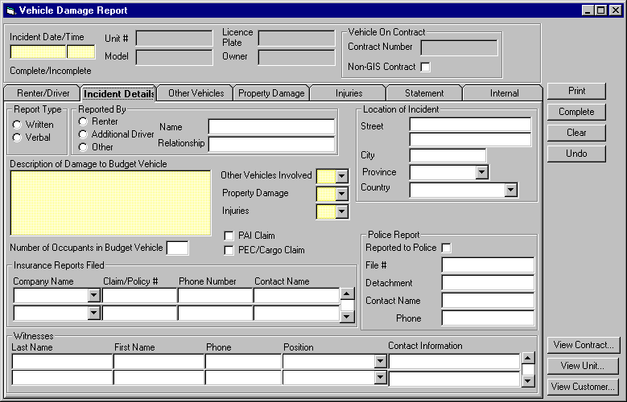
Purpose
The incident details tab allows the user to enter the following incident details:
- date & time
- location
- information on the person making the report
- whether a PAI, PEC or cargo insurance claim is being filed.
- a description of damage to the Budget vehicle and the number of occupants
- whether there are other vehicles involved, property damage or injuries
- information on any insurance reports that have been filed
- information an any police report that has been filed
- information on any witnesses to the incident
If Other Vehicles Involved is Yes, details for at least one other vehicle must have been entered in the Other Vehicles tab before the damage report can be printed or completed.
If Property Damage is Yes, details for at least one occurrence of property damage must have been entered in the Property Damage tab before the damage report can be printed or completed.
If Injuries is Yes, details for at least one injury must have been entered in the Injuries tab before the damage report can be printed or completed.
Navigation
N/A
Functions
N/A
Controls (cont.)
Field | Source | Req* | Validation | Comments
Report Type
Written/Verbal | Vehicle Damage Report, Report Type | Y |  | No default.
Reported By
Renter/  Additional Driver/  Other | Vehicle Damage Report, Reported By Role | Y |  | Defaults to Renter if Claim, Result Of is Contract and to Other otherwise. Renter and Additional Driver will be disabled if Claim, Result Of is not Contract.
Name | Vehicle Damage Report, Reported By Name | S |  | Required if Reported By is not Renter and Report Type is Written.
Relationship | Vehicle Damage Report, Reported By Relationship | S |  | Required if Reported By is Other and Report Type is Written.
Location of Incident
Street | Vehicle Damage Report, Street 1 & Street 2 | N
City | Vehicle Damage Report, City | N
Province/State | Vehicle Damage Report, Province | N | Controlled by the Province/State table if Country is Canada or US.
Country | Vehicle Damage Report, Country | N | Controlled by the Country table.
Controls (cont.)
Field | Source | Req* | Validation | Comments
Description of Damage to Budget Vehicle | Vehicle Damage Report, Damage Description | S |  | Required if Report Type is Written.
Number of Occupants of Budget Vehicle | Vehicle Damage Report, Number of Occupants | N | Numeric, >= zero
Other Vehicles Involved | Vehicle Damage Report, Other Vehicles Involved | S | Yes/No | Required if Report Type is Written.
Property Damage | Vehicle Damage Report, Property Damage | S | Yes/No | Required if Report Type is Written.
Injuries | Vehicle Damage Report, Injuries | S | Yes/No | Required if Report Type is Written.
PAI Claim | Vehicle Damage Report, PAI Claim | N |  | Disabled unless PAI on the Renter/Driver tab is visible and is ‘Included’ or ‘Accepted’.
PEC Claim | Vehicle Damage Report, PEC Claim | N |  | Disabled unless PEC on the Renter/Driver tab is visible and is ‘Included’ or ‘Accepted’.
Cargo Claim | Vehicle Damage Report, Cargo Claim | N |  | Disabled unless Cargo Insurance on the Renter/Driver tab is visible and is ‘Included’ or ‘Accepted’.
Controls (cont.)
Field | Source | Req* | Validation | Comments
Insurance Reports Filed
Company Name | Insurance Report, Company Name | N |  | Entry assisted by Insurance Company table.
Claim/Policy # | Insurance Report, Claim/Policy Number | N
Phone Number | Insurance Report, Phone Number | N
Contact Name | Insurance Report, Contact Name | N
Police Report
Reported to Police | Vehicle Damage Report, Reported to Police | N
File # | Vehicle Damage Report, Police File Number | N
Detachment | Vehicle Damage Report, Police Detachment | N
Contact Name | Vehicle Damage Report, Police Contact Name | N
Contract Phone | Vehicle Damage Report, Police Contact Phone | N
Controls (cont.)
Field | Source | Req* | Validation | Comments
Witnesses
Last Name | Witness, Last Name | N
First Name | Witness, First Name | N
Last Name | Witness, Last Name | N
Phone | Witness, Phone Number | N
Position | Witness, Position | N |  | Entry assisted by Witness Position table
Contact Information | Witness, Contact Information | N
Technical Notes

Other Vehicles Tab
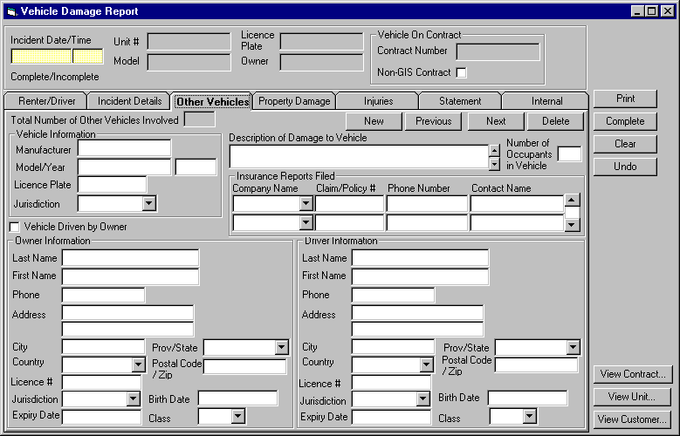
Purpose
The other vehicles tab allows the user to enter the details for any other vehicles involved in the incident. The total number of other vehicles recorded is displayed at the top right of the tab and buttons at the top left of the tab allow the user to record details for a new vehicle, view the previous or next vehicle or delete the current vehicle displayed.
Navigation
N/A
Functions
New: Clear the vehicle information on the tab so that the user can enter information for a new vehicle.
Previous: Display the information for the previous vehicle (vehicles will be displayed in the sequence in which they were entered.
Next: Display the information for the next vehicle (vehicles will be displayed in the sequence in which they were entered.
Delete: Delete the vehicle currently displayed.
Controls (cont.)
Field | Source | Req* | Validation | Comments
Total Number of Other Vehicles Involved |  | D |  | Calculated by GIS.
Vehicle Information
Manufacturer | Other Vehicle, Manufacturer | N
Model/Year | Other Vehicle, Model | N
 | Other Vehicle, Year | N | Year
Licence Plate | Other Vehicle, Licence Plate | N
Jurisdiction | Other Vehicle, Licence Jurisdiction | N |  | Entry assisted by Licence Jurisdiction table.
Description of Damage to Vehicle | Other Vehicle, Damage Description | N |  | Required if Report Type is Written.
Number of Occupants in Vehicle | Other Vehicle, Number of Occupants | N | Numeric, >= zero
Insurance Reports Filed
Company Name | Other Vehicle Insurance, Company Name | N |  | Entry assisted by Insurance Company table.
Claim/Policy # | Other Vehicle Insurance, Claim/Policy Number | N
Controls (cont.)
Field | Source | Req* | Validation | Comments
Phone Number | Other Vehicle Insurance, Phone Number | N
Contact Name | Other Vehicle Insurance, Contact Name | N
Vehicle Driven By Owner | Other Vehicle, Driven By Owner | N
Owner Information
Last Name | Other Vehicle, Owner Last Name | N
First Name | Other Vehicle, Owner First Name | N
Phone | Other Vehicle, Owner Phone Number | N
Address | Other Vehicle, Owner Address 1 & Owner Address 2 | N
City | Other Vehicle, Owner City | N
Province/State | Other Vehicle, Owner Province | N | Controlled by the Province/State table if Country is Canada or US.
Country | Other Vehicle, Owner Country | N | Controlled by the Country table.
Controls (cont.)
Field | Source | Req* | Validation | Comments
Postal Code/Zip | Other Vehicle, Owner Postal Code | N | Must match Canadian postal code format if Country is Canada. Must match US zip code format if country is US.
Licence # | Other Vehicle, Owner Licence Number | N
Jurisdiction | Other Vehicle, Owner Licence Jurisdiction | N
Birth Date | Other Vehicle, Owner Birth Date | N | Date (no time)
Expiry Date | Other Vehicle, Owner Licence Expiry | N | Date (no time).
Class | Other Vehicle, Owner Licence Class | N | Must match entry on BC Driver Licence Class table if Province is BC. | Entry assisted by BC Driver Licence Class table.
Driver Information |  |  |  | Only visible when Vehicle Driven by Owner is No
Last Name | Other Vehicle, Driver Last Name | N
First Name | Other Vehicle, Driver First Name | N
Controls (cont.)
Field | Source | Req* | Validation | Comments
Phone | Other Vehicle, Driver Phone Number | N
Address | Other Vehicle, Driver Address 1 & Address 2 | N
City | Other Vehicle, Driver City | N
Province/State | Other Vehicle, Driver Province | N | Controlled by the Province/State table if Country is Canada or US.
Country | Other Vehicle, Driver Country | N | Controlled by the Country table.
Postal Code/Zip | Other Vehicle, Driver Postal Code | N | Must match Canadian postal code format if Country is Canada. Must match US zip code format if country is US.
Licence # | Other Vehicle, Driver Licence Number | N
Jurisdiction | Other Vehicle, Driver Licence Jurisdiction | N
Birth Date | Other Vehicle, Driver, Birth Date | N | Date (no time)
Expiry Date | Other Vehicle, Driver Licence Expiry | N | Date (no time).
Controls (cont.)
Field | Source | Req* | Validation | Comments
Class | Other Vehicle, Driver Licence Class | N | Must match entry on BC Driver Licence Class table if Province is BC. | Entry assisted by BC Driver Licence Class table.

Property Damage Tab
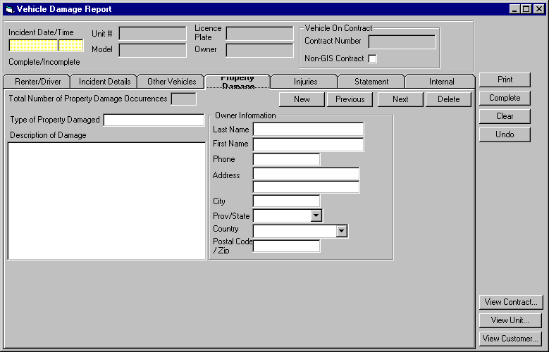
Purpose
The property damage tab allows the user to enter the details for any property damage related to the incident. The total number of property damage occurrences recorded is displayed at the top right of the tab and buttons at the top left of the tab allow the user to record details for new property damage, view the previous or next property damage or delete the current property damage displayed.
Navigation
N/A
Functions
New: Clear the property damage on the tab so that the user can enter new property damage information.
Previous: Display the information for the previous property damage (property damage will be displayed in the sequence in which it was entered.
Next: Display the information for the next property damage (property damage will be displayed in the sequence in which it was entered.
Delete: Delete the property damage currently displayed.
Controls (cont.)
Field | Source | Req* | Validation | Comments
Total Number of Property Damage Occurrences |  | D |  | Calculated by GIS.
Type of Property Damaged | Property Damage, Property Type | N
Description of Damage | Property Damage, Damage Description | N
Owner Information
Last Name | Property Damage, Owner Last Name | N
First Name | Property Damage, Owner First Name | N
Phone | Property Damage, Owner Phone Number | N
Address | Property Damage, Owner Address 1 & Owner Address 2 | N
City | Property Damage, Owner City | N
Province/State | Property Damage, Owner Province | N | Controlled by the Province/State table if Country is Canada or US.
Controls (cont.)
Field | Source | Req* | Validation | Comments
Country | Property Damage, Owner Country | N | Controlled by the Country table.
Postal Code/Zip | Property Damage, Owner Postal Code | N | Must match Canadian postal code format if Country is Canada. Must match US zip code format if country is US.

Injuries
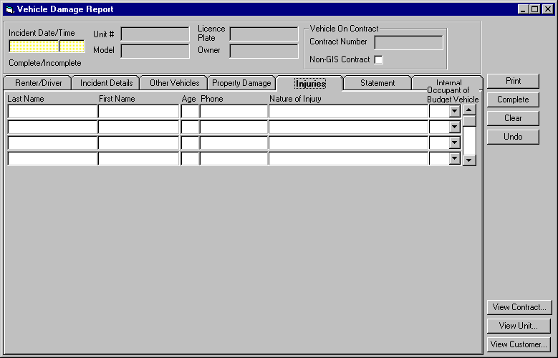
Purpose
The injuries tab allows the user to enter the details of any injuries related to the incident.
Navigation
N/A
Functions
N/A
Controls (cont.)
Field | Source | Req* | Validation | Comments
Last Name | Injury, Last Name | N
First Name | Injury, First Name | N
Age | Injury, Age | N | Numeric, >= zero
Phone | Injury, Phone Number | N
Nature of Injury | Injury, Nature of Injury | N
Occupant of Budget Vehicle | Injury, Occupant of Budget Vehicle | N | Yes/No

Statement
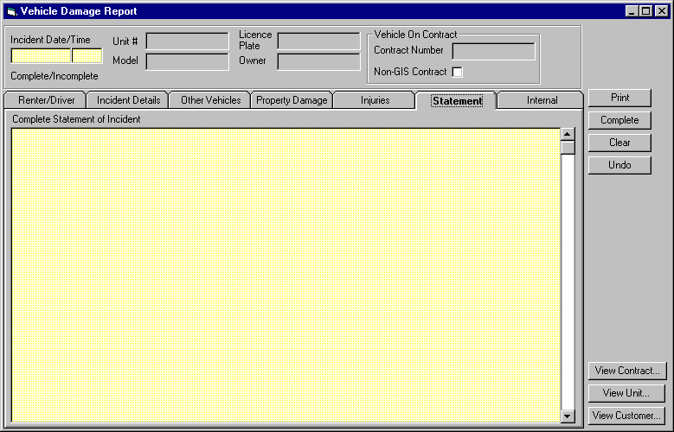
Purpose
The statement tab allows the user to enter the incident statement provided by the person reporting the incident. A written damage report cannot be completed until a statement has been entered.
Navigation
N/A
Functions
N/A
Controls (cont.)
Field | Source | Req* | Validation | Comments
Complete Statement of Incident | Vehicle Damage Report, Statement | S |  | Required when Report Type is Written before the Complete button can be used.

Internal
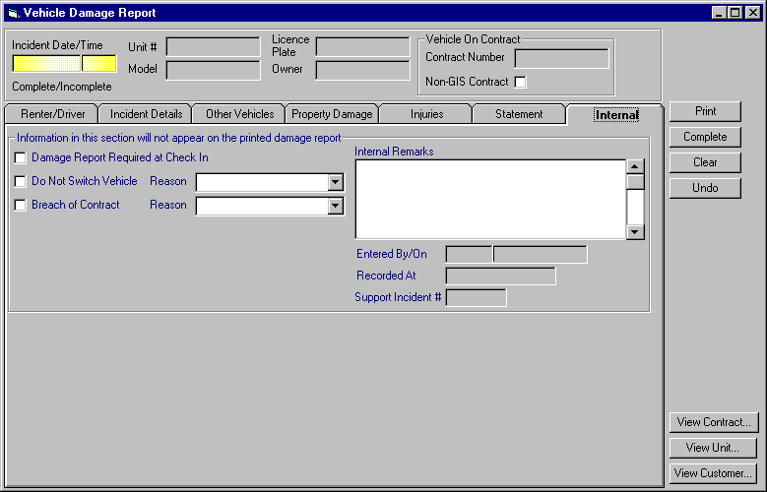
Purpose
The internal tab allows the user to enter information that will not appear on the printed damage report.
Navigation
N/A
Functions
N/A
Controls (cont.)
Field | Source | Req* | Validation | Comments
Damage Report Required at Check In | Vehicle Damage Report, Damage Report Required at Check In | N |  | Not visible unless Claim, Result Of is Contract.
Do Not Switch Vehicle | Vehicle Damage Report, Do Not Switch Vehicle | N |  | Not visible unless Claim, Result Of is Contract.
Reason | Vehicle Damage Report, Do Not Switch Reason | S |  | Not visible unless Claim, Result Of is Contract.  Required if Do Not Switch Vehicle is Yes.  Entry assisted by the Do No Switch Reason table.
Breach of Contract | Vehicle Damage Report, Breach of Contract | N |  | Not visible unless Claim, Result Of is Contract.
Reason | Vehicle Damage Report, Breach of Contract Reason | S |  | Not visible unless Claim, Result Of is Contract.  Required if Breach of Contract is Yes.  Entry assisted by the Breach of Contract Reason table.
Internal Remarks | Vehicle Damage Report, Internal Remarks | N
Entered By/On | Vehicle Damage Report, Entered By/On | D
Recorded At | Vehicle Damage Report, Recorded At Location | D |  | Not visible unless Report Type is Written.  Location Name is displayed.
Controls (cont.)
Field | Source | Req* | Validation | Comments
Support Incident # | Claim, Vehicle Support Incident Number | D |  | Not visible unless Claim, Result Of is Contract and Report Type is Verbal.
Technical Notes
Do Not Switch Vehicle Flag
If Vehicle Damage Report, Do Not Switch Vehicle is Yes when Save is pressed, set Contract, Do Not Switch Vehicle to Yes if the incident is being logged for a movement.
If Vehicle Damage Report, Do Not Switch Vehicle is No when Save is pressed and Contract, Do Not Switch Vehicle is Yes, check to see if there are any other Vehicle Damage Reports or any Vehicle Support Incidents for the Contract where Do Not Switch Vehicle is Yes. If there aren’t any, set Contract, Do Not Switch Vehicle to No.

Reports
Reports to be designed by Budget personnel at a future date.

Vehicle Damage Report
tbd

tbd
list to be provided by Budget

Retrofits to Existing Screens

Contract Changes During Rental – Replace Vehicle Tab
- The Vehicle Support Incident button will open the vehicle support incident screen and allow the CSR to view the incident. The CSR will not be able to open a claim from here.
- If there is a vehicle support incident for the vehicle on contract where the ‘Damage Report Required At Check In’ flag has been turned on then a ‘Damage Report’ button will be visible. This button will be red and button will open up the claim for the vehicle on contract and allow the CSR to view existing damage reports and add new ones or directly open a new vehicle damage report for the existing claim. The CSR will not be able to replace the vehicle without entering a damage report.
If there is more than one vehicle support incident for the vehicle on contract where the ‘Damage Report Required at Check In’ flag has been turned on the CSR will be shown a list of the list existing claim(s) and asked if they want to access one of those or open a new claim. This functionality will be the same as described in Vehicle Support Incident above.
- If there are no vehicle support incidents for the vehicle on contract where the ‘Damage Report Required At Check In’ flag has been turned on then an ‘Open Claim’ button will be visible. This button will function as described for the Vehicle Support Incident screen.

Contract Check In – Check In Tab
- Same as for the Contract Changes During Rental – Replace Vehicle tab.

Contract Adjustments – Payment Tab
- An Open Claim button will be added to this tab. This button will function as described for the Vehicle Support Incident screen.

Vehicle Support Incident – Details Tab
- The Open Claim button needs to be available for Stolen incidents as well.
- If a claim already exists for the vehicle on contract, non-GIS contract or movement, the user will be shown a list of the list existing claim(s) and asked if they want to access one of those or open a new claim.
Dennis will determine information should show up on this list and what wording should be used.
- If the user specifies an existing claim, the claim screen will be opened for the claim selected and the user will be able to add a damage report or view an existing damage report.
- If the user decides to open a new claim the claim screen will be opened for a new claim. The claim will be assigned to the same vehicle on contract, non-GIS contract or movement that the vehicle support incident was opened for and this information will be locked. The user will then be able to record a vehicle damage report.
- When a support incident is saved and Damage Report Required At Check In is turned off, the program will need to check Vehicle Damage Reports for the contract as well as other Vehicle Support Incidents for the contract, in order to decide whether Damage Report Required At Check In can be turned off at the contract level as well.
- Vehicle Support sometimes gets called when damage is discovered outside of a movement or contract. In this case, the vehicle will be moved to the shop and the incident report will be opened during the movement (the business design for Vehicle Support states that vehicle support incidents can only be opened when a vehicle is checked out on a contract or in transit).

Foreign Check In – Check In Tab
- Same as for the regular check in screen. The foreign check in screen will have to search for any vehicle support incidents recorded for the foreign contract number, as vehicle support incidents may have been recorded without entering the contract onto GIS. If the contract had been recorded on GIS, the regular Check In screen will be used instead of the Foreign Check In screen.

Vehicle Movement
- An Open Claim button will be added to this screen (in the Receive section). This button will function as described for the Vehicle Support Incident screen.

Tables without Maintenance Screens
- Do Not Switch Vehicle Reason
- Breach of Contract Reason
- Insurance Company Name
- Witness Position

Data Model

Revision History

Version 2.00
- Clean up documentation and make consistent with the GIS standards.

